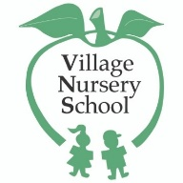 VNS 2021 Summer
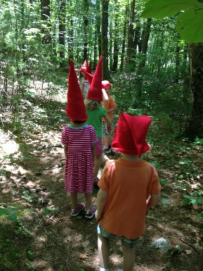
Outdoor summer nature fun at VNS!
Lead by VNS teachers, children will explore themed nature activities and enjoy our outdoor areas, including our Nature Trail, Nature Nook, and Village Woods.

June 14-17 – The Wonder of the Woods
June 21-24 – Bugs and Things That Fly
June 28-July 1 -Fourth of July Fun

Sample Schedule
9-10 - Drop off
- indoor/outdoor activities (art, science, sensory)
10-11:30- Outdoor activities (outdoor games, nature walk, nature exploration)
11:30-12 – lunch
12 – Threes dismissal
  - - Water play, stories, games
1 - Dismissal
*Please send your child in a bathing suit and a mask with a nut free snack (Threes), or lunch each day, a towel, and sunscreened and bug sprayed.
*Please return the sign up below with payment to secure your child’s spot. Groups are limited to 12 children each.

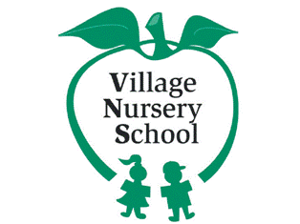 Village Nursery School
2021 Young Explorers Summers Program

Please return this form with payment to secure your child’s spot

Week 1 June 14-17 (M-TH) Wonder of The Woods
(9-12) Seedlings $150 tuition (children entering a Threes program in the fall)
(9-1) Saplings $200 tuition (children entering Young Fours or Pre-K in the
fall))
(9-1) Birches $200 tuition (children entering kindergarten in the fall)

Week 2 June 21-24 (M-TH) Bugs and Things That Fly
(9-12) Seedlings $150 tuition (children entering a Threes program in the fall)
(9-1) Saplings $200 tuition (children entering Young Fours or Pre-K in the
fall))
(9-1) Birches $200 tuition (children entering kindergarten in the fall)

Week 3 June 28-July 1 (M-TH) Fourth of July Fun
(9-12) Seedlings $150 tuition (children entering a Threes program in the fall)
(9-1) Saplings $200 tuition (children entering Young Fours or Pre-K in the
fall))
(9-1) Birches $200 tuition (children entering kindergarten in the fall)

Child’s Name: ________________________________________________
Program:____________________________________________________
Weeks:______________________________________________________

check
Paypal

