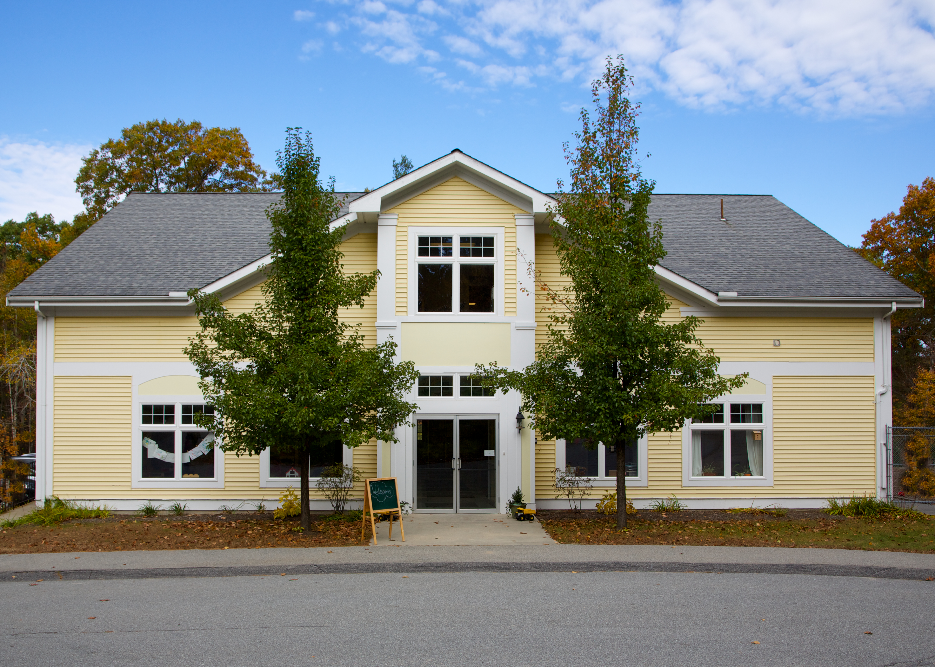

VILLAGE NURSERY SCHOOL BRICK ORDER FORM

Name email phone

Bricks cost $100 each. Up to 3 lines per brick and 20 characters/spaces per line. The fewer the characters the larger the engraving will appear.

BRICK 1 ______________________________________________________________________________________

BRICK 2 ______________________________________________________________________________________

BRICK 3 ______________________________________________________________________________________

BRICK 4 ______________________________________________________________________________________

BRICK 5 ______________________________________________________________________________________

Total # Bricks: ___________________ Total Amount Enclosed: __________________

*Please make checks payable to VNS and note “brick” in the memo*

